Lam Research (LRCX)
Too far outside sweet spot
However, understanding Lam is essential for understanding the 3D NAND and eSSD upgrade cycle that benefits
companies like Pure Storage and Micron. Lam's etch and deposition tools are what make 200+ layer memory stacks
possible.
Category: Equipment (Etch & Deposition)
Est. Price Per Unit: $3M - $5M per tool (~$5M+ per chamber)

What They Do

Product 101 and Where They Fit into the AI Stack
Lam is the leader in semiconductor etch equipment (~45% global share) and #2 in deposition (behind Applied Materials).
Etch explained: after material is deposited on a wafer, etch tools selectively remove material to create 3D structures.
Deposition is "painting," etch is "sculpting."
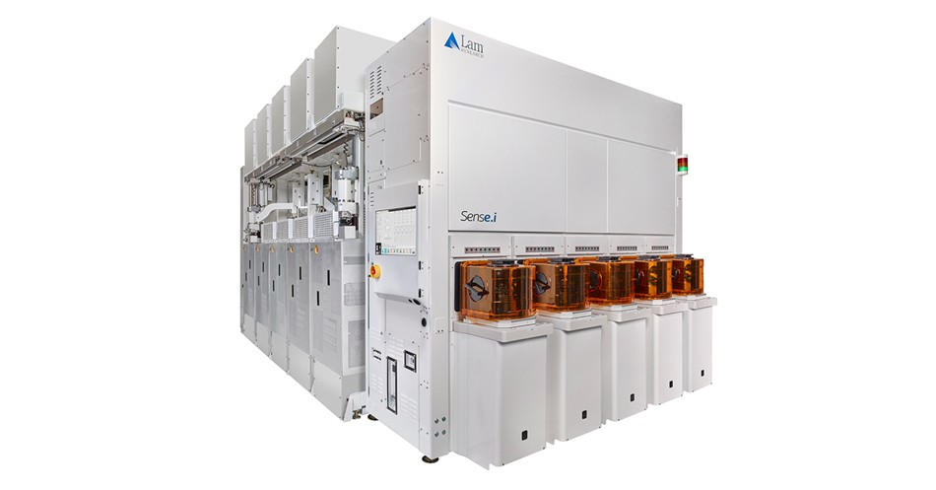
Why this matters for AI: unlike 2D NAND (lithography-enabled), 3D NAND is deposition and etch enabled. Building 200+ layer memory towers requires etching vertical channels at aspect ratios exceeding 100:1. This is Lam's specialty.
Key products:
Cryo 3.0: cryogenic etch technology targeting 1,000-layer 3D NAND. Uses extreme cold for cleaner vertical etches.
Flex and Vantex: high aspect ratio etch systems for memory hole etching
Altus Halo: molybdenum ALD system, selected for three consecutive nodes at a leading customer for 500+ layer
NAND
The challenge: etching a trillion holes per wafer at >100:1 aspect ratios without bowing, twisting, or incomplete etching. This is edge-of-physics engineering.

Alignment with Overall Thesis
AI is driving demand for high-capacity storage. Data centers need enterprise SSDs with higher layer counts. ~2/3 of NAND capacity remains at older nodes—significant upgrade potential.
The industry is targeting 1,000-layer 3D NAND by ~2030. Every layer transition requires more etch and deposition steps.
Lam scales with complexity.
Also benefits from HBM production (etch/deposition for memory stacking), though smaller than NAND exposure.
Shipped $1B+ each for gate-all-around nodes and advanced packaging in 2024; 2025 combined expected to exceed $3B.

Business Model, Customers
~$5M+ per machine per chamber.
Node transition purchasing dynamic—bought when fabs move to new nodes or build capacity. Also scales with material transitions (tungsten to molybdenum).
Higher memory exposure (NAND, DRAM) than Applied Materials, which is more logic-balanced. More cyclicality, but more leverage to 3D NAND upgrades.
Customers: memory IDMs (Samsung, SK Hynix, Micron) and leading logic fabs (TSMC, Intel).

Comments on Team
Founder David Lam started the company in 1980 and left in early 1990s.
Professional management. CEO Tim Archer joined in 2012, became CEO in 2018.
Engineering-driven culture focused on customer collaboration and process integration.

Early View of Moat Hypothesis
High aspect ratio etch leadership. Etching at 100:1 is edge-of-physics. Lam has a decade+ head start in cryogenic etch.
Process integration—Lam co-develops processes with memory makers. Creates lock-in.
Winning material transitions (tungsten to molybdenum). Altus Halo selected for three consecutive nodes at a leading customer.

Why They're Interesting, and Why Now
AI data explosion drives demand for higher-capacity storage. Enterprise SSDs with 200+ layer 3D NAND are the near-term solution. Lam's tools are the bottleneck enablers.
NAND spending is recovering in 2025—driven by technology upgrades rather than capacity expansion. Healthier growth dynamics.
Our view: Lam is a great company with direct AI exposure through 3D NAND and HBM. But it's a $100B+ incumbent with memory cyclicality risk. We prefer expressing the storage complexity theme through Pure Storage, which benefits from NAND advances without cyclical equipment exposure.

Key Risks
Memory cyclicality. NAND is boom/bust. When prices crash, capex freezes. Lam is more exposed than Applied Materials.
China concentration—significant revenue at risk from export restrictions.
Applied Materials has broader scale and is pushing into etch. Tokyo Electron competitive in Asia.

Gaps in Understanding / Key Questions
How much of NAND recovery is priced in? Duration of upgrade cycle?
Is the HAR etch moat durable as competitors invest? Gap vs. Tokyo Electron?
What portion of revenue is truly AI-driven vs. general NAND/DRAM capacity?

Select Financial Graphs

R1: Total Revenue & YoY Growth
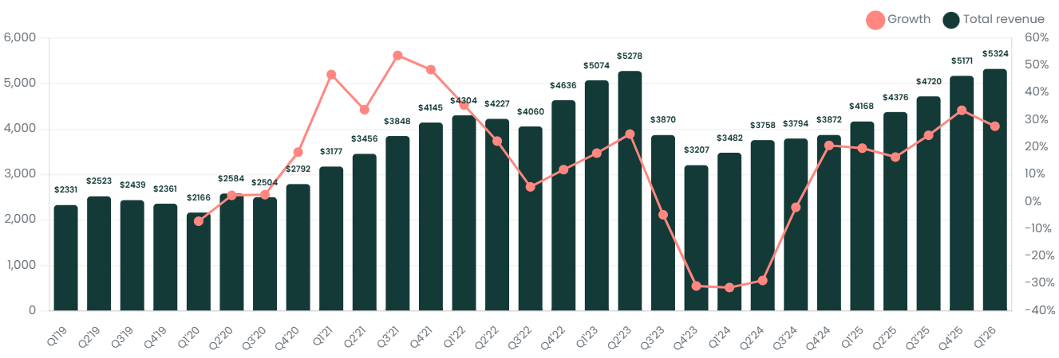

I1: Inventory Turnover
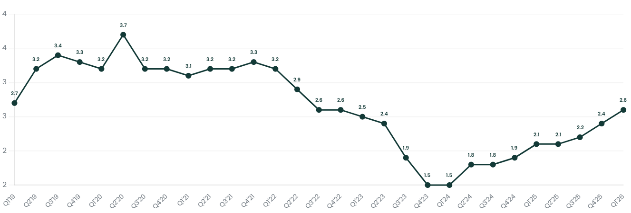

P3: EBIT Margin
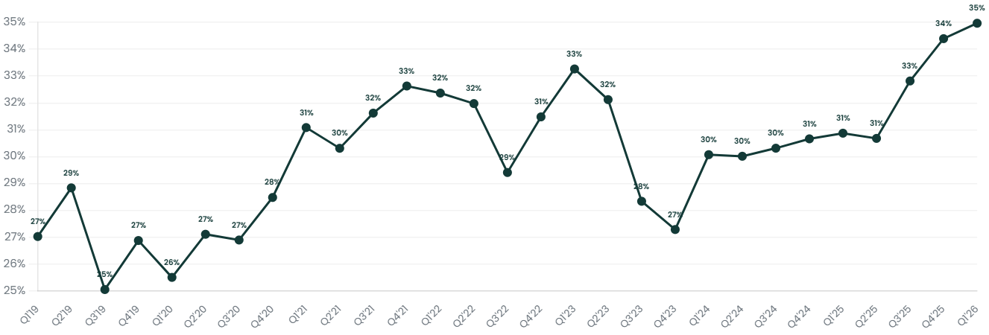

S3: Revenue by Memory Type
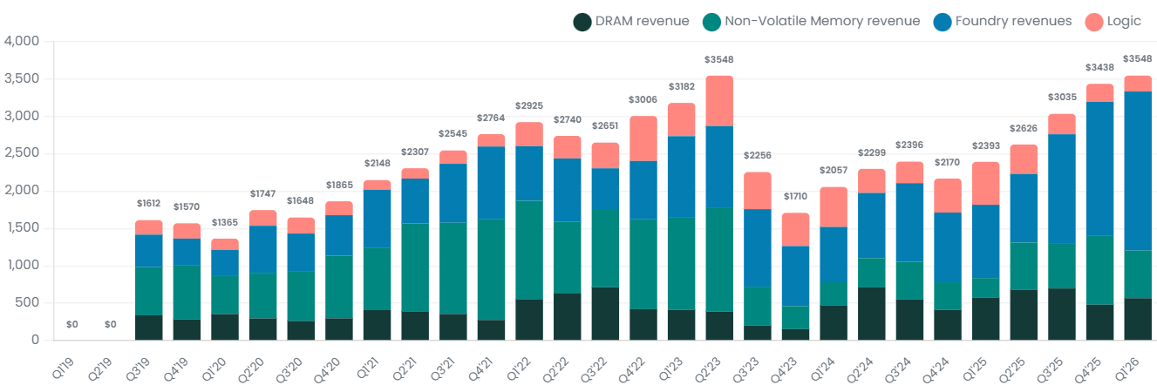

S4: Memory Type Mix
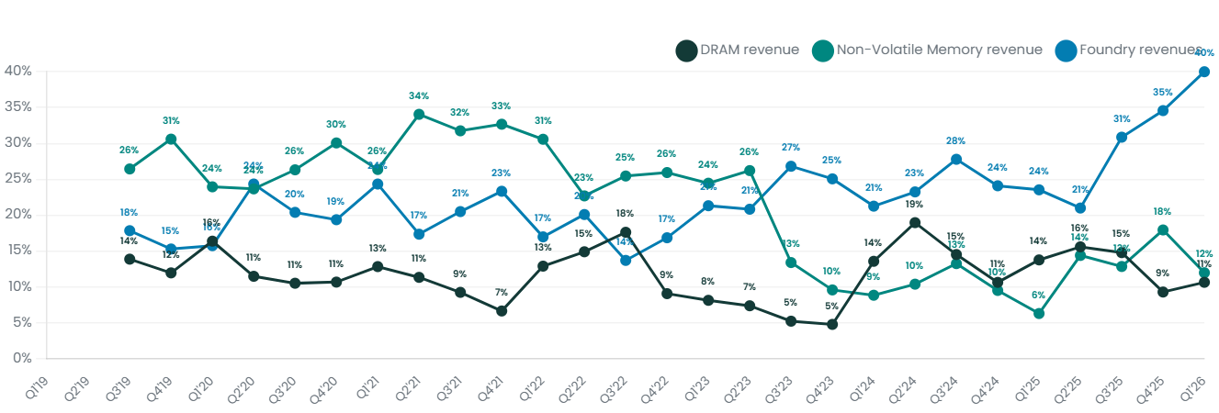

Patent Analysis

3D NAND Patent Timeline
AMAT leads in 3D NAND patents by volume. Lam has fewer filings but consistent presence. Note: patent volume doesn't always correlate with market position—Lam's etch leadership may be more about process know-how than patent count.
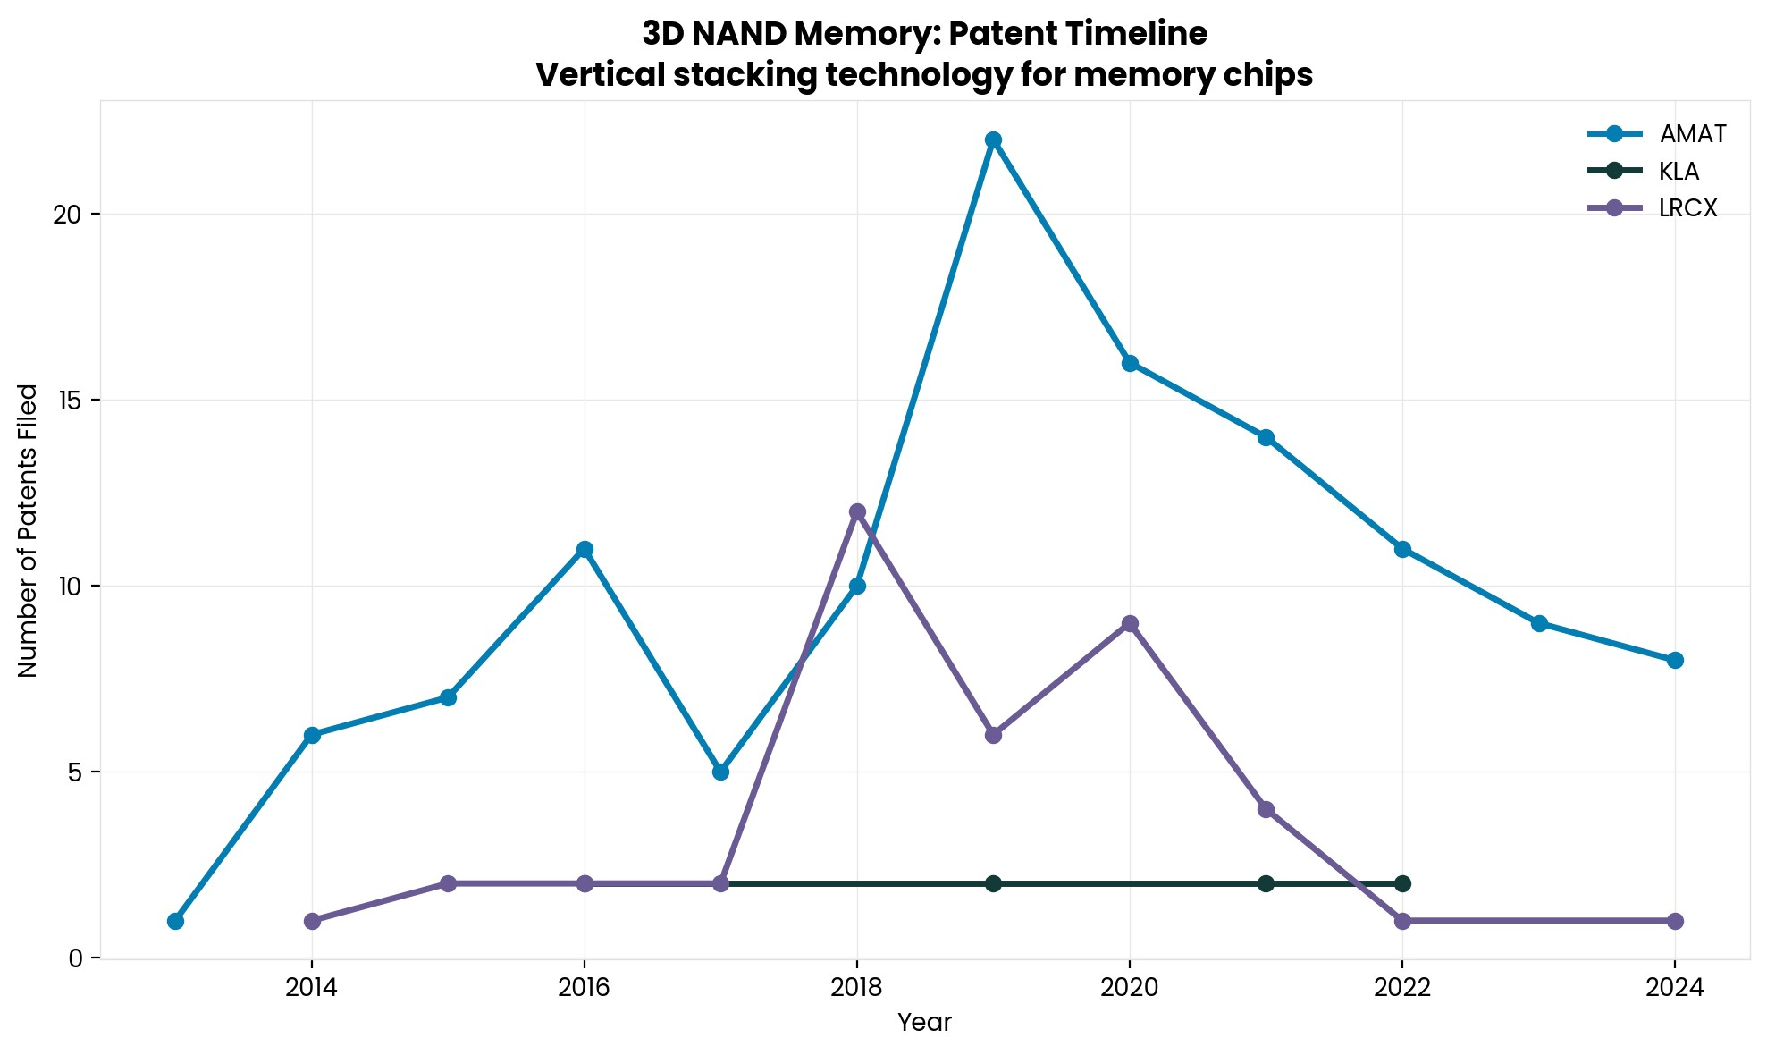

Deposition & Etch: AMAT vs LRCX
AMAT dominates EUV and 3D NAND patent filings. Lam's citation rate has historically been competitive with AMAT, suggesting quality over quantity.
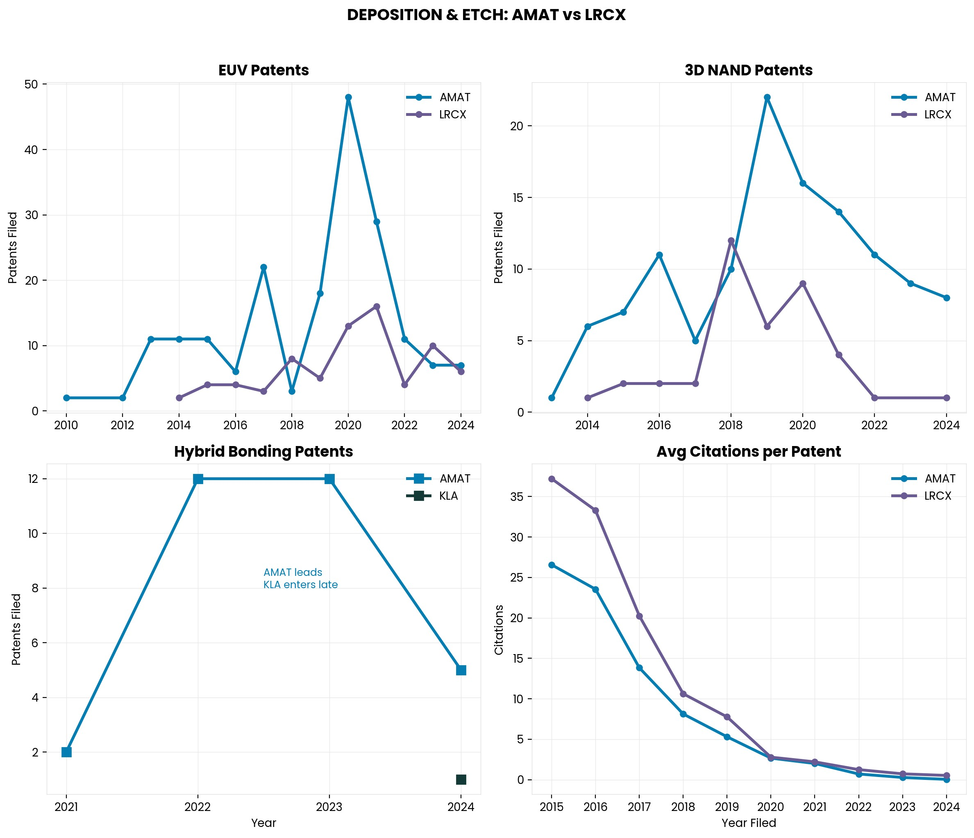

Interesting Topics to Read
3D NAND scaling path to 1,000 layers
High Aspect Ratio (HAR) etch technology
Cryogenic etch vs. conventional plasma etch
Tungsten to molybdenum transition in NAND
Lam Research vs. Applied Materials competitive dynamics
Memory cycle history and capex patterns

